MINIMUM SPANNING TREE

ALGORITHMS

- KRUSKAL’S ALGORITHM

- PRIM’S ALGORITHM

Minimum Spanning Tree - Definition

- Given a connected and undirected graph, G (V, E), a spanning tree of that graph is a subgraph that is a tree and connects all the vertices together.

- A single graph can have many different spanning trees.

- A minimum spanning tree (MST) or minimum weight spanning tree for a weighted, connected and undirected graph is a spanning tree with weight less than or equal to the weight of every other spanning tree.

- The weight of a spanning tree is the sum of weights given to each edge of the spanning tree.

- A minimum spanning tree has (V – 1) edges where V is the number of vertices in the given graph.

Kruskal’s algorithm
Steps for finding MST
- Sort all the edges in non-decreasing (increasing) order of their weight.
- Pick the smallest edge. Check if it forms a cycle with the spanning tree formed so far. If cycle is not formed, include this edge. Else, discard it.
- Repeat step#2 until there are (V-1) edges in the spanning tree.
EXAMPLE
- The algorithm is a Greedy Algorithm.
- The Greedy Choice is to pick the smallest weight edge that does not form a cycle in the MST constructed so far.

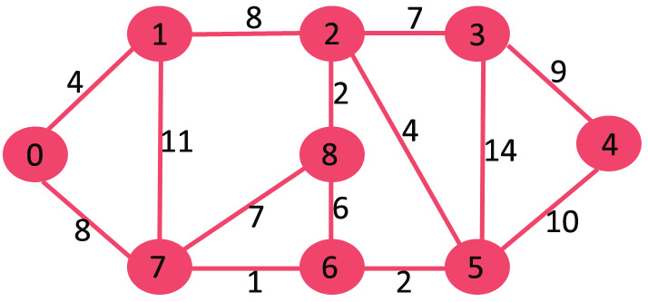

- The graph contains 9 vertices and 14 edges. So, the minimum spanning tree formed will be having (9 – 1) = 8 edges

After sorting:

Weight Source Dest
1 7 6
2 8 2
2 6 5
4 0 1
4 2 5
6 8 6
7 2 3
7 7 8
8 0 7
8 1 2
9 3 4
10 5 4
11 1 7
14 3 5

Now pick all edges one by one from sorted list of edges
1. Pick edge 7-6: No cycle is formed, include it.

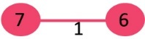

2. Pick edge 8-2: No cycle is formed, include it.

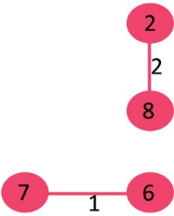

3. Pick edge 6-5: No cycle is formed, include it.

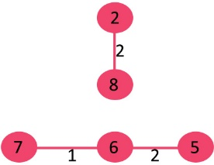
Steps 4.& 5 ?

6. Pick edge 8-6: Since including this edge results in cycle, discard it.

7. Pick edge 2-3: No cycle is formed, include it.

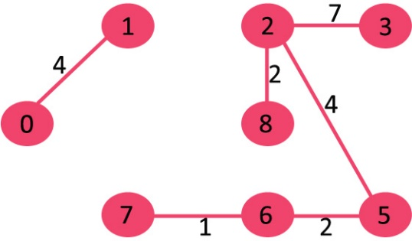

8. Pick edge 7-8: Since including this edge results in cycle, discard it.

9. Pick edge 0-7: No cycle is formed, include it.

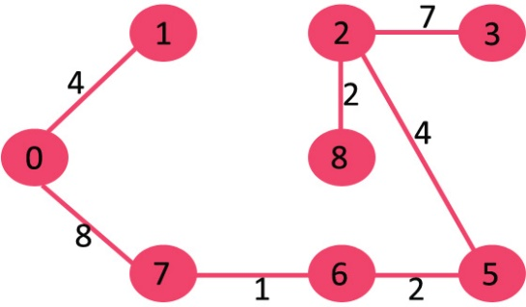

10. Pick edge 1-2: Since including this edge results in cycle, discard it.

11. Pick edge 3-4: No cycle is formed, include it.

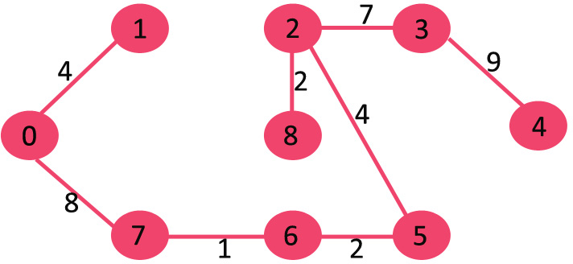

- Since the number of edges included equals (V – 1), the algorithm stops

Time Complexity: O(E log E) or O(E log V).

